"Anytime, Anywhere!"
Available 24 hrs a day, 7 days a week
Phone: 757-342-9010
GSA Contract GS-21F-0053V
ksimpson@87engines.com

Marine Engine Maintenance, Inc. has been awarded GSA Contract No: GS-21F-0053V for Dockside Maintenance and Repair Services SIN 812-002. Marine Engine Maintenance, Inc. is fully dedicated to providing quality technical advice and service to the marine industry. The company provides Factory Trained and Certified (M3, E4) MTU 396 Series Technician with over 8 years experience on MTU's and 27 years experience on diesel engines.
Our services include:
Electronic Troubleshooting
Preventive Maintenance and Repairs
W5 and W6 MTU Engine Maintenance
Inconel Shielding
24-Hour Emergency Service
ODR Repair
Rebuilding Injector Nozzles
Y19 Cable assembly
Generator Repair and Installation
Display Installation
Hydraulic Hose Renewal
Reconditioning of Heads
REBUILDS:
Raw Water Pump Rebuild
Jacket Water Pump Rebuild
Turbocharger Rebuild
If you don't see what you need, call us at 757-342-9010.

Background
Marine Engine Maintenance, Inc (MEM, Inc) is a Veteran Service Disabled owned company established in 1989. The company possesses experience in the marine engine, marine electrical and marine electronics business. The president and owner of MEM, Inc, is a retired Senior Chief USCG possessing 27 years of experience in marine engine, engine electrical and engine electronics maintenance, overhaul and repair.
MEM, Inc. is an emerging small business for NAICS codes 336611 and 811310 and a small business for 541990. The last three years the company has successfully repaired and maintained the USCG fleet of 87 CPB vessels in the Atlantic and Pacific. MEM, Inc. currently has an IDIQ contract with US Coast Guard, MLC Pacific with a potential contract value of $2,707,597.77. The contract is for major top end maintenance every six years or 7000 engine hours and emergency response on an as needed basis. MEM, Inc is mobile. The company possesses two trucks and one forty-four foot trailer. The trailer fully encloses the workshop. The company has all tools and equipment necessary to fulfill all work described in this proposal. The maintenance and repair work is performed by a staff of 3 technicians which the company employs. Each possesses a minimum of five (5) years experience and at least two (2) years of college. When additional personnel are required, as a result of work obtained by the company, additional personnel are hired for the individual project. A list of suitable personnel is maintained by the company. The company possesses a fully factory trained technician to include Electrical level 4 (E4) and Mechanical level 3 (M3) for the Motoren Und Turbin Union (MTU) 396 series engines. Copies of the certificates for MTU are attached to this brochure, to illustrate the training of the technicians. MEM, Inc. has successfully been awarded contracts and simplified acquisitions from the US Coast Guard as provided in the past performance portion of this brochure. The company continues to obtain relevant training and experience through communications with MTU, Cummins, Detroit Diesel and other engine manufacturers. Through these training experiences, access to proprietary information is obtained and maintained.
MEM, Inc. manages its accounting processes and the awarded contracts utilizing Quickbooks accounting and estimating software to track all expenditures and inventory. When GFE is provided, the parts are received, observed for condition, checked against the established parts list for the engine under contract, and a GFE document is mutually signed by the U. S. Government and MEM, Inc. If there are any discrepancies in GFE, the company provides a condition found report (CFR) to the agency for its action.
PAST PERFORMANCE –
Marine Engine Maintenance, Inc. encourages agencies to contact our clients to discuss our capabilities and customer service.
U.S. Coast Guard Pacific POC Valerie Rivera-Chase Phone No: 510-637-5972 Contract No: HSCG85-07-D-625143 Project: IDIQ for dockside Maintenance of the Motor turbine Union (MTU) Main engine Operations W5 on various 87 foot Patrol Boats located in the Pacific. Value: $2,707,597
U.S. Coast Guard Pacific (U.S.C.G. PIKE) POC Gilbert Hernandez or MKC Waggoner Phone No: 510-637-5972 Purchase Order No: HSCG85-P-625864 Project: Troubleshooting and repairing of electronic Casualty on Main Diesel engine (MDE #2) Value: $5,050.00
U.S. Coast Guard Pacific (U.S.C.G. Sockeye) POC: Valerie Rivera-Chase Phone No: 510-637-5972 Purchase Order No: HSCG85-08-J-625C25 Project: Overhaul MDE Value: $181,815.00
FACILITIES AND EQUIPMENT
Marine Engine Maintenance, Inc. (MEM, Inc.) is totally mobile. The fully contained shops are enclosed within a forty four (44) foot trailer. Also used are two trucks for GFE and other related work needs. In 2008, MEM, Inc. acquired new stationary facilities in Orange Beach, AL. This facility will provide expanded capability to perform certified testing and other large engine projects.

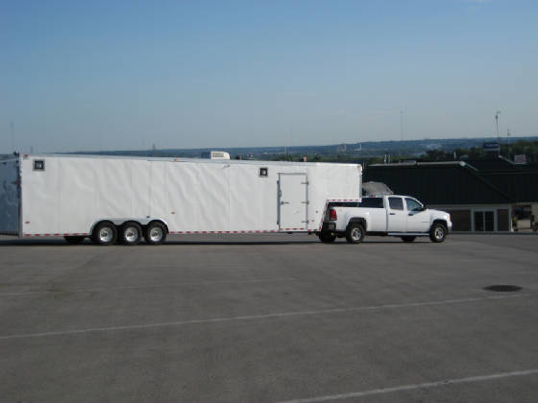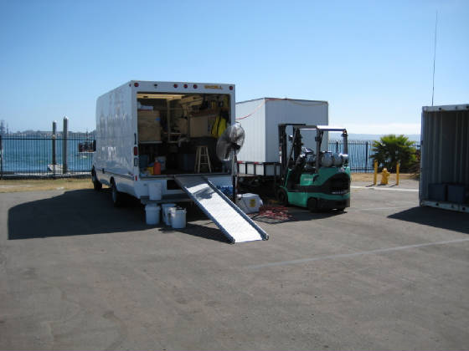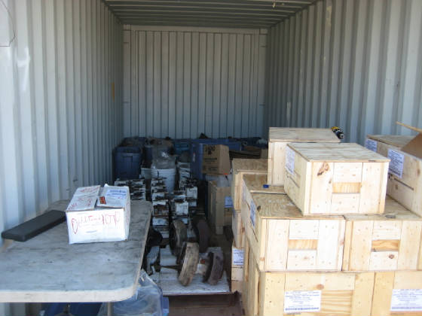
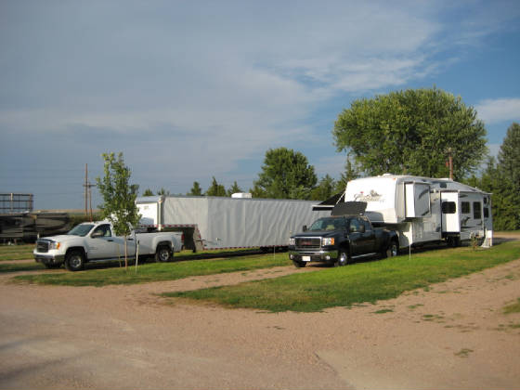
CERTIFIED TRAINING CERTIFICATES
Provided are copies of the training certificates for Kevin Simpson in relation to MTU engines.


